**PROJECT 1**

DATA DESCRIPTION :

**This dataset contains attributes related to crimes taking place in various areas like type of** **crimes:**

FBI code related to that criminal case, arrest frequency, location ofcrime etc.

The various fields in the data in the followining order

ID,Case Number,Date,Block,IUCR,Primary Type,Description,Location

Description,Arrest,Domestic,Beat,District,Ward,Community

Area,FBICode,X Coordinate,Y Coordinate,Year,Updated On, Latitude, Longitude ,Location .

**QN1 1. Write a mapreduce and pig program to calculate the number of cases investigated under each FBI code.**

**DRIVER CLASS:** 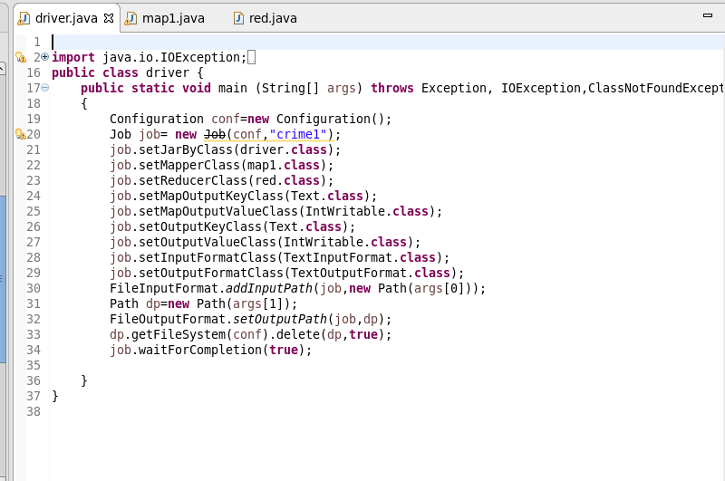

**MAPPER CLASS:**

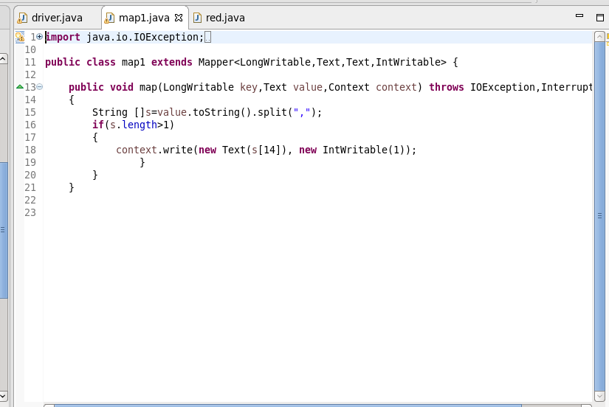

**REDUCER CLASS:**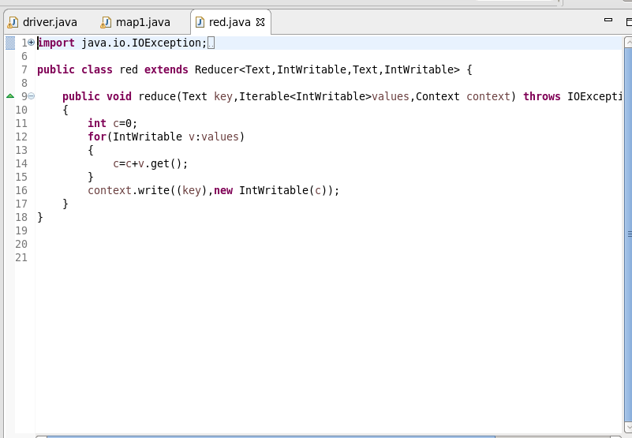

**OUTPUT:** 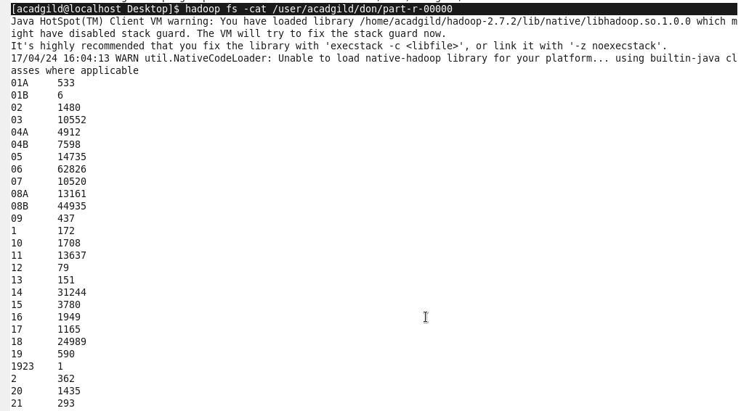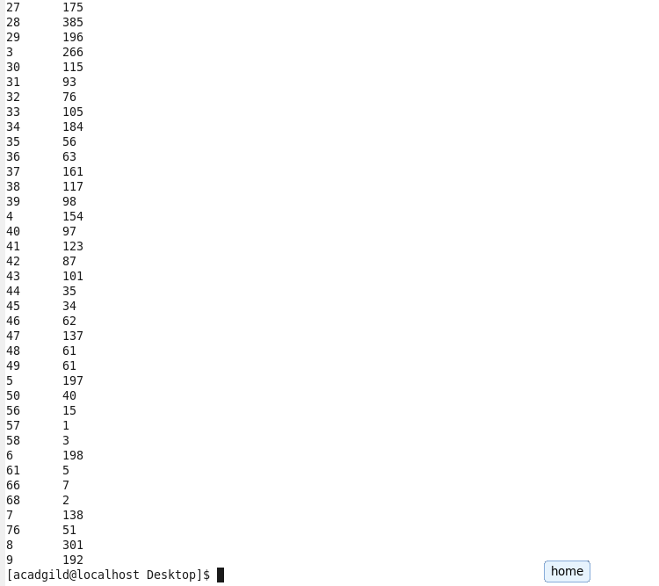

**PIG SCRIPT :**

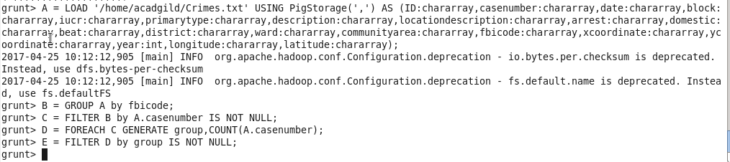

**OUTPUT :** 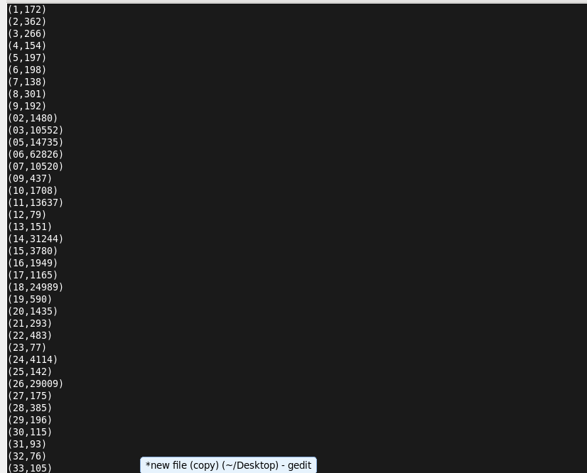

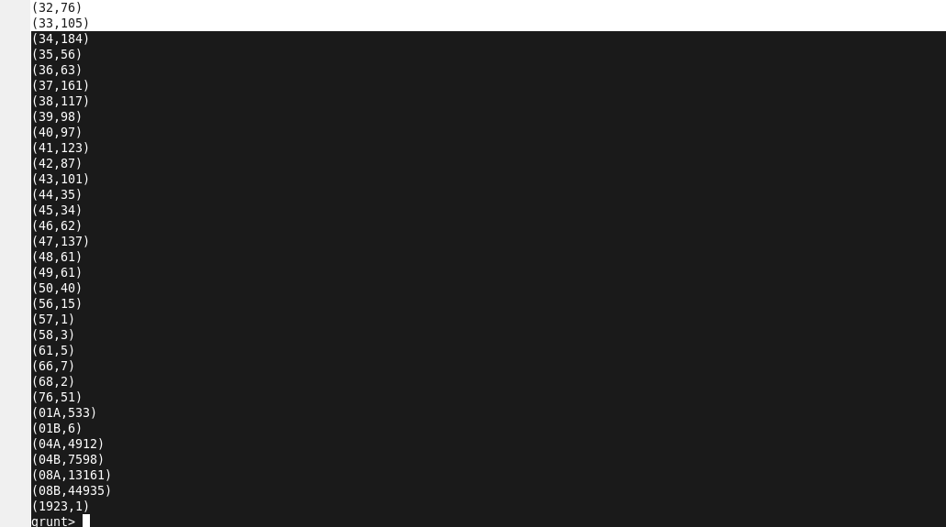

**QN2: Write a mapreduce and pig program to calculate the number of cases investigated under FBI code 32.**

**DRIVER CLASS:** 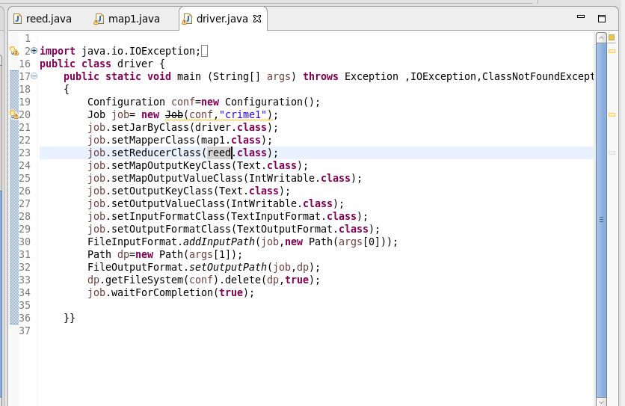

**MAPPER CLASS:**

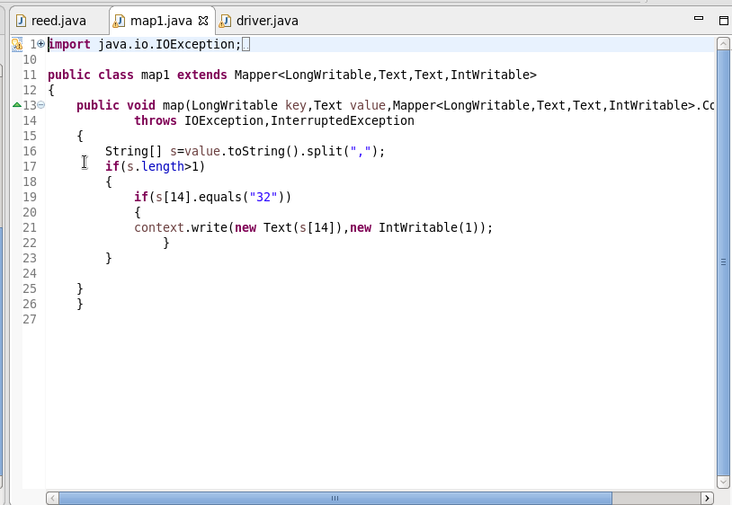

**REDUCER CLASS:**

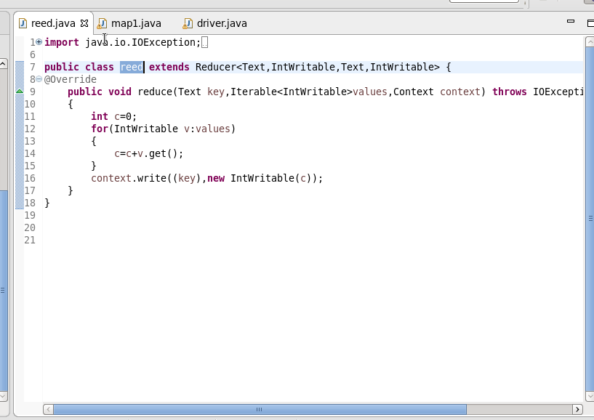

**OUTPUT :**

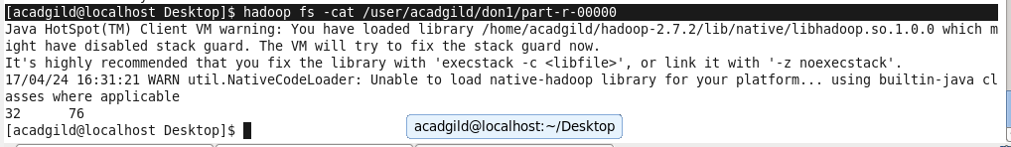

**PIG SCRIPT :**

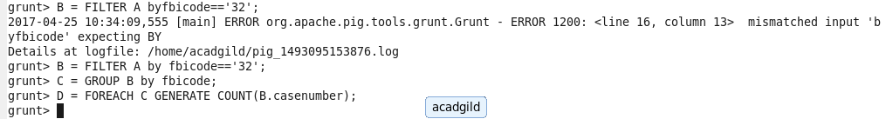

**OUTPUT:**



**QN3. Write a mapreduce and pig program to calculate the number of arrests in theft district wise.**

**DRIVER CLASS:**

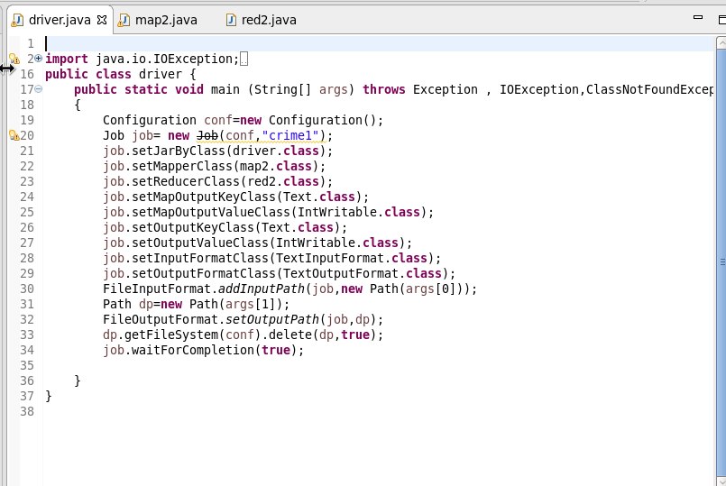

**MAPPER CLASS:**

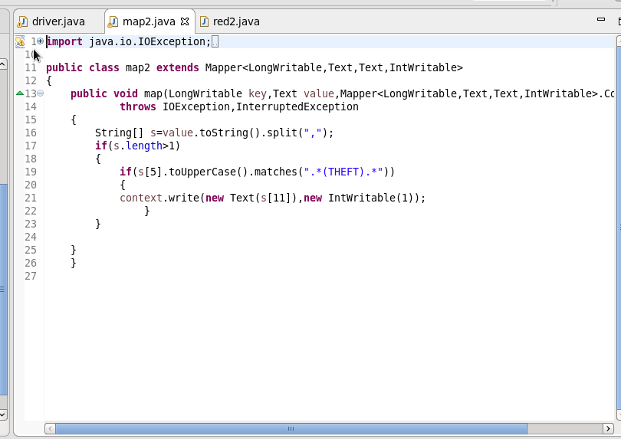

**REDUCER CLASS :**

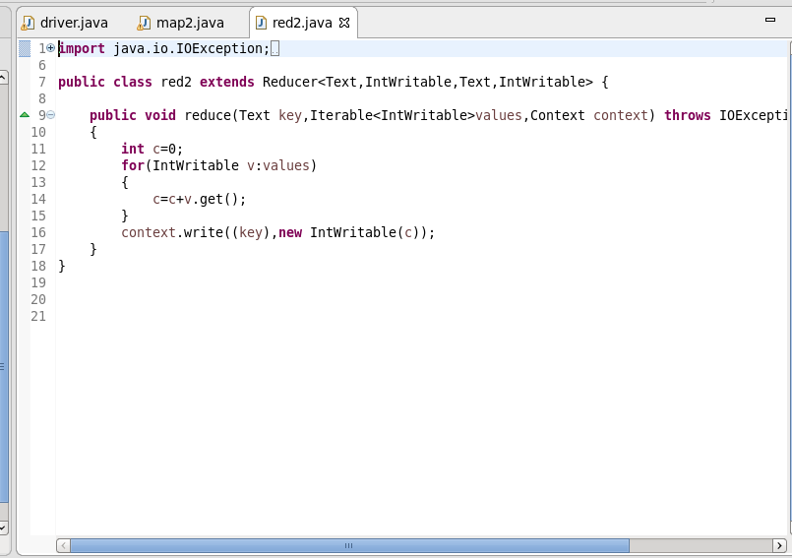

**OUTPUT :**

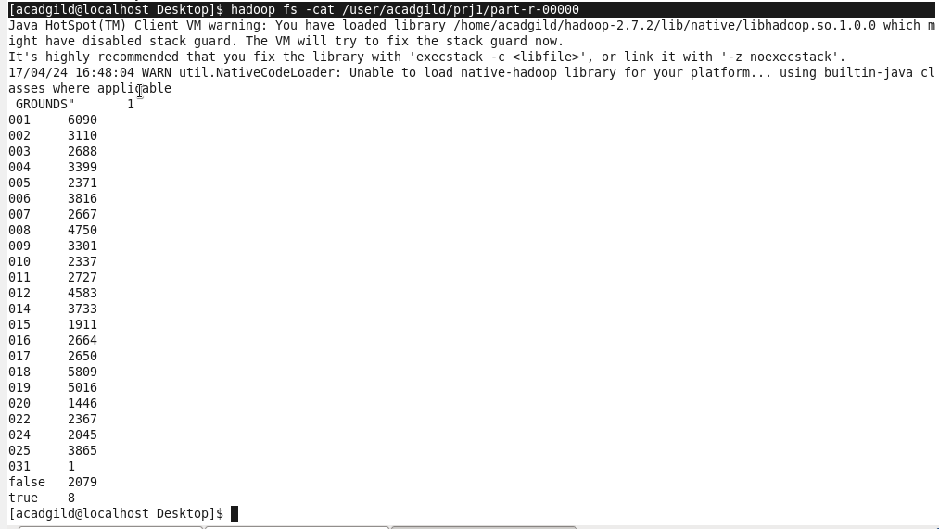

**PIG SCRIPT:**

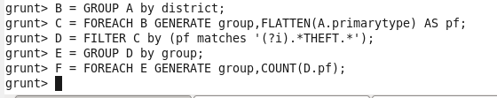

**OUTPUT:**

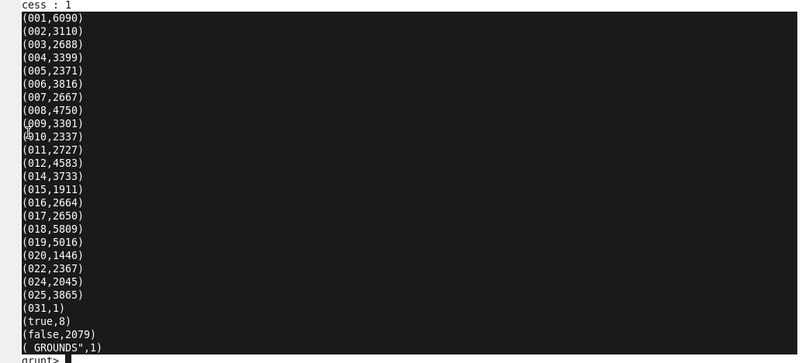

**QN4.Write a mapreduce and pig program to calculate the number of arrests done between October 2014 and October 2015.**

**DRIVER CLASS :**

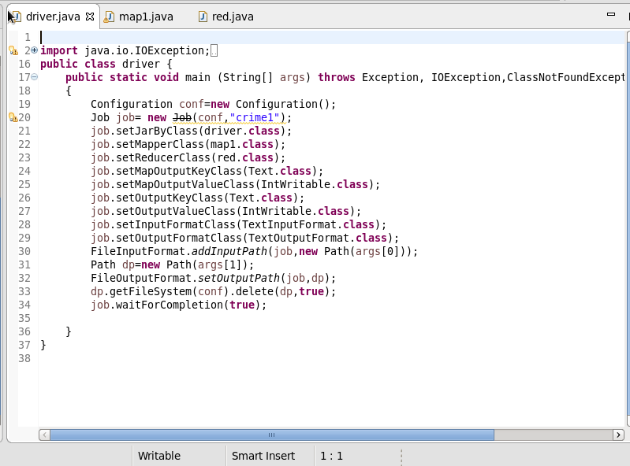

**MAPPER CLASS :** 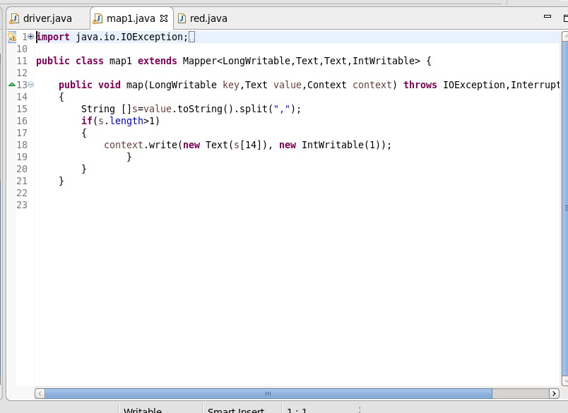

**REDUCER CLASS :**

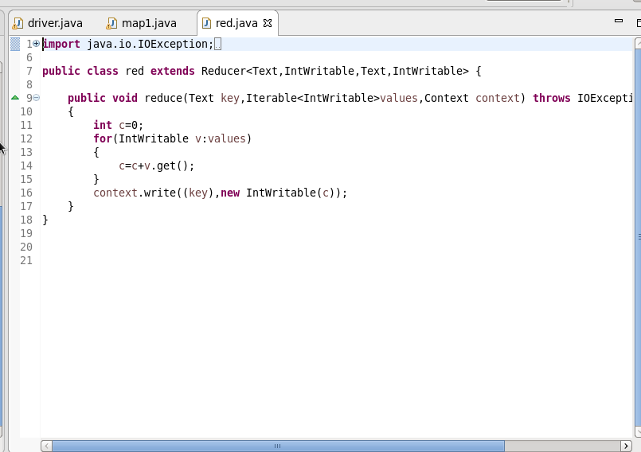

**OUTPUT:**

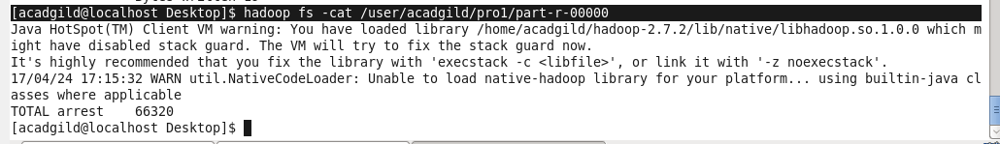

**PIG SCRIPT:**

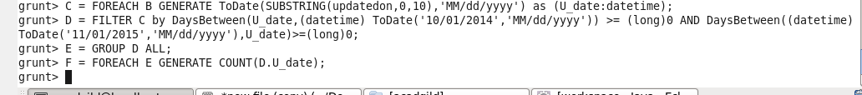

**OUTPUT: **